Northwind Traders Sales Analysis
This report aims to generate insights into customer behavior, sales patterns, and employee performance to aid decision-making processes. It will cover sales analysis, customer segmentation, inventory trends, and employee performance, consolidating data from multiple tables for a comprehensive view of the company's operations. The report will empower stakeholders to make data-driven decisions by offering valuable insights and facilitating data exploration through interactive visualizations and dynamic filters.
We have below tables
Customers Table
This table stores information about the company's customers. It includes fields for customer ID, company name, contact name, contact title, address, city, region, postal code, country, phone, and fax.
Employees Table
This table stores information about the company's employees. It includes fields for employee ID, last name, first name, title, title of courtesy, birth date, hire date, address, city, region, postal code, country, home phone, extension, photo, notes, reports to, and photo path.
Orders Table
This table stores information about the company's orders. It includes fields for order ID, customer ID, employee ID, order date, required date, shipped date, ship via, freight, ship name, ship address, ship city, ship region, ship postal code, and ship country.
Order Details Table
This table stores detailed information about the items within each order. It includes fields for order ID, product ID, unit price, quantity, and discount.
Products Table
This table stores information about the company's products. It includes fields for product ID, product name, supplier ID, category ID, quantity per unit, unit price, units in stock, units on order, reorder level, and whether the product is discontinued.

Suppliers Table
This table stores information about the company's suppliers. It includes fields for supplier ID, company name, contact name, contact title, address, city, region, postal code, country, phone, fax, and home page.
Shippers Table
This table stores information about the company's shipping companies. It includes fields for shipper ID, company name, and phone.
Categories Table
This table stores information about the product categories. It includes fields for category ID, category name, and description.
- Step1-Data cleaning
Cleaned all CSV files as stated below and then saved as CSV
1.Customers –
- Deleted image and image thumbnail columns
- changed 1 st row as header
- Replaced multiple blank values in Region column with other
2.Suppliers-
- deleted links column
- Replaced multiple blank values in Region column with other
3.Orders-
- In Shipregion column Replaced multiple blank values in Region column with other
- Change datatype of all date related columns to date
4.Orderdetails-
- Created ‘totalamount’ column
- Where totalamount=price*quantity-discount*price*quantity
5.employees-
- Deleted photo column

- Step2-Data analysis in MYSQL
Imported all 8 data csv folders then perform further cleaning if needed
Performed EDA for 15 different Questions

-- 1.What is the average number of orders per customer? Are there high-value repeat customers?;

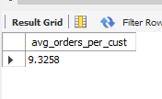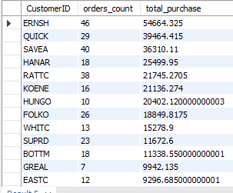
So average order/customer is appx 9,and putting conditions of year=1996, order count>5 ,total_purchase>2000 so we got 46 high value customers.

2.How do customer order patterns vary by city or country?;
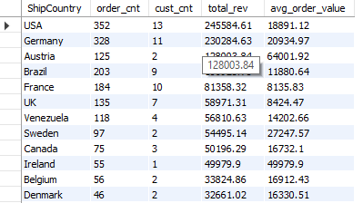
3.Can we cluster customers based on total spend, order count, and preferred categories?;
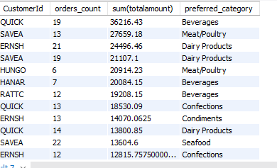

4.Which product categories or products contribute most to order revenue?;

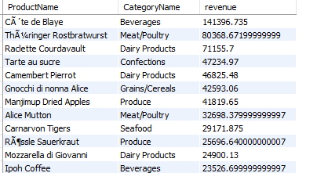

5 .Are there any correlations between orders and customer location or product category?;
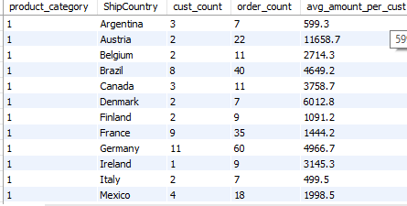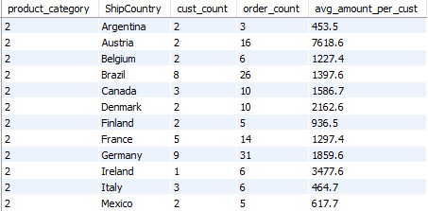
Here I have shown output for only 2 categories but actually there are 8 categories

6.How frequently do different customer segments place orders?;

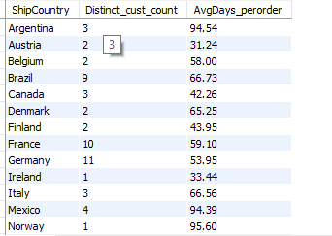

7.What is the geographic and title-wise distribution of employees?
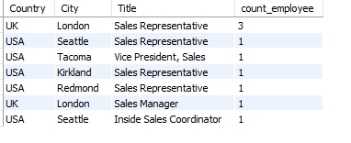

8.What trends can we observe in hire dates across employee titles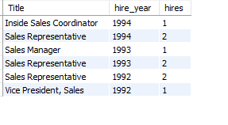

9.What patterns exist in employee title and courtesy title distributions?;
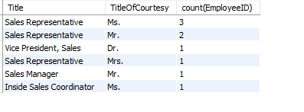

10.Are there correlations between product pricing, stock levels, and sales performance?;
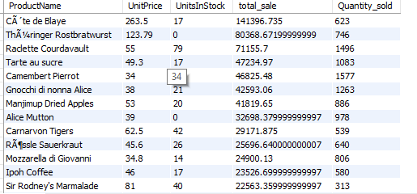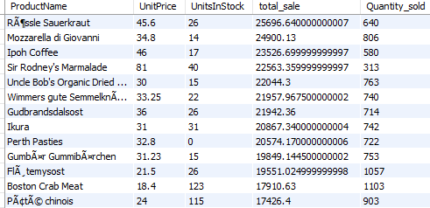
11.How does product demand change over months or seasons?;
`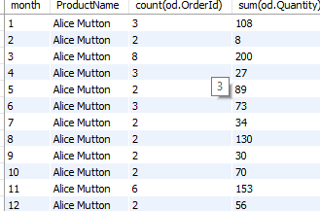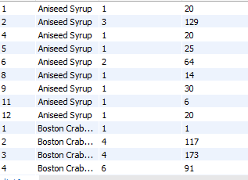
Out of multiple products I have shown some of them

12. Can we identify anomalies in product sales or revenue performance?;
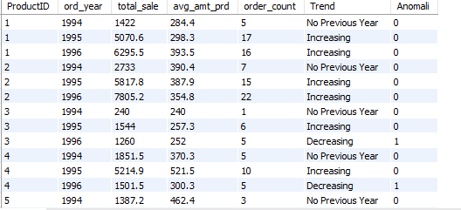

13. Are there any regional trends in supplier distribution and pricing?;
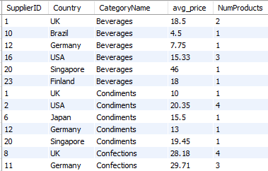
14.How are suppliers distributed across different product categories?;
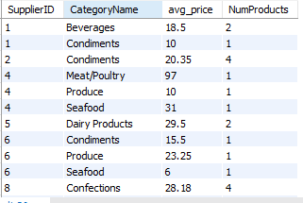–

15.How do supplier pricing and categories relate across different regions?;

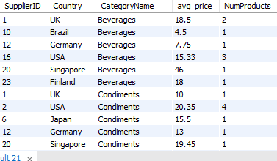

Step3-EDA in excel
- Imported same 8 cleaned datasets in excel, cleaned them in power query if necessary ,then I add them to data model .In power pivot ‘manage relationship’ section I performed data modelling ,joined those table together on their primary and foreign keys,here I used one to many relationships.
- Created data dictionary for files
- After that I pasted each questions sql code and output window beneath it and then tried to find out same answer in pivot table ,then performed charting of final output
OrderDetails | OrderID | Foreign key referencing each order placed. | Integer | 10248 | FK → Orders.OrderID
OrderDetails | ProductID | Foreign key referencing the product ordered. | Integer | 11 | FK → Products.ProductID
OrderDetails | UnitPrice | Price per unit of the ordered product. | Decimal | 14
OrderDetails | Quantity | Quantity of product ordered in the order. | Integer | 12
OrderDetails | Discount | Discount applied on the order line. | Decimal (0–1) | 0.05
OrderDetails | TotalAmount | Total sale amount after applying discount. | Decimal | 159.6 | Calculated field
Orders | OrderID | Unique identifier assigned to each sales order. | Integer | 10248 | PK
Orders | CustomerID | Foreign key linking to the customer who placed the order. | Text | ALFKI | FK → Customers.CustomerID
Orders | EmployeeID | Foreign key referencing the employee who handled the order. | Integer | 5 | FK → Employees.EmployeeID
Orders | ShipVia | Foreign key referencing the shipping company used. | Integer | 2 | FK → Shippers.ShipperID
Orders | OrderDate | Date when the order was placed. | Date | 1996-07-04
Orders | ShippedDate | Date when the order was shipped. | Date | 1996-07-16
Orders | ShipName | Name of the shipper used. | Text | Speedy Express
Orders | ShipAddress | Full shipping address. | Text | 59 rue de l’Abbaye
Customers | CustomerID | Unique identifier for each customer. | Text | ALFKI | PK
Customers | CompanyName | Name of the customer's company. | Text | Alfreds Futterkiste
Customers | ContactName | Name of the contact person. | Text | Maria Anders
Customers | ContactTitle | Job title of the contact person. | Text | Sales Representative
Customers | Address | Street address of the customer. | Text | Obere Str. 57
Products | ProductID | Unique identifier for each product. | Integer | 11 | PK
Products | ProductName | Name of the product. | Text | Queso Cabrales
Products | SupplierID | Foreign key referencing supplier. | Integer | 5 | FK → Suppliers.SupplierID
Products | CategoryID | Foreign key referencing category. | Integer | 4 | FK → Categories.CategoryID
Products | UnitPrice | Price per product unit. | Decimal | 21
Products | UnitsInStock | Quantity of product currently in stock. | Integer | 22
Products | UnitsOnOrder | Quantity currently on order. | Integer | 30
Products | Discontinued | 0 = Active, 1 = Discontinued. | Boolean | 0
Categories | CategoryID | Unique identifier for product category. | Integer | 4 | PK
Categories | CategoryName | Name of the category. | Text | Dairy Products
Categories | Description | Description of category. | Text | Cheeses, butter, and milk products.
Suppliers | SupplierID | Unique identifier for suppliers. | Integer | 5 | PK
Suppliers | CompanyName | Name of the supplier company. | Text | Cooperativa de Quesos ‘Las Cabras’
Suppliers | ContactName | Contact person at supplier company. | Text | Antonio del Valle Saavedra
Suppliers | ContactTitle | Contact person’s title. | Text | Sales Representative
Suppliers | Address | Supplier’s address. | Text | Calle del Rosal 4
Employees | EmployeeID | Unique identifier for employees. | Integer | 5 | PK
Employees | EmployeeName | Full name of employee (First + Last). | Text | Steven Buchanan
Employees | Title | Job title of the employee. | Text | Sales Manager
Employees | HireDate | Date of joining. | Date | 1993-10-17
Employees | Address | Employee address. | Text | 14 Garrett Hill
Employees | Notes | Additional background or achievements. | Text | Fluent in French and Japanese
Employees | ReportsTo | Supervisor’s employee ID. | Integer | 2 | Self-join: Employees.EmployeeID
Shippers | ShipperID | Unique identifier for shipping company. | Integer | 2 | PK
Shippers | ShipperName | Name of the shipping company. | Text | United Package
Shippers | Phone | Contact number for shipper. | Text | (503) 555-3199

Above is our excel data dictionary
Here is our excel
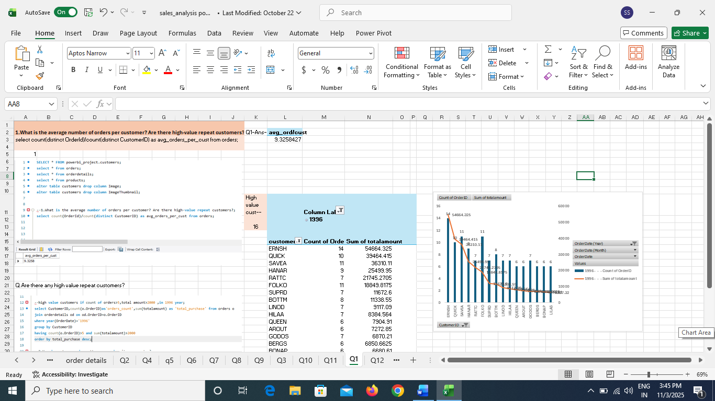
Step4-EDA in power bi
- Imported same 8 cleaned csv files in powerbi,performed if more cleaning is needed in power Query editor
- Changed data type if needed.
- Created calculated columns, Measured columns if needed.
- Created ‘bins range’ columns for different histograms
- Made use of different types of charts as requirement like line chart,scatter chart,clustered bar/column,stack bar/column chart,map chart ,box plot chart etc
- Finaly made a appealing Dashboard out of that insights.
Here are our Business Questions-
- How does customer distribution vary across different countries or cities? Use bar chart or map to visualize.
- What is the trend in customer orders over time? Use line chart or area chart to visualize.
- What is the distribution of customers by Contact Title or Region? Use stacked bar chart or pie chart to visualize.
- How does order volume change over time? Use line chart or stacked bar chart to visualize.
- What is the distribution of order values? Use histogram or box plot to visualize.
- What is the average order shipping duration? Use bar chart or box plot to visualize.
- What is the count of employees by job title or region? Use stacked bar chart or tree map to visualize.
- What is the distribution of employee tenure? Use histogram or box plot to visualize.
- What is the reporting structure among employees? Use org chart or hierarchical tree to visualize.
- Which products have the highest sales volume? Use bar chart or tree map to visualize.
- How does the sales volume vary across different product categories? Use stacked bar chart or tree map to visualize.
- Can we visualize the pricing distribution of products? Use box plot or histogram to visualize.
- How many products are supplied by each supplier? Use bar chart or pie chart to visualize.
- How does product pricing vary across different suppliers? Use box plot or stacked column chart to visualize.
- What is the geographical distribution of suppliers? Use map chart or bubble map to visualize.
Here is our ER diagram- *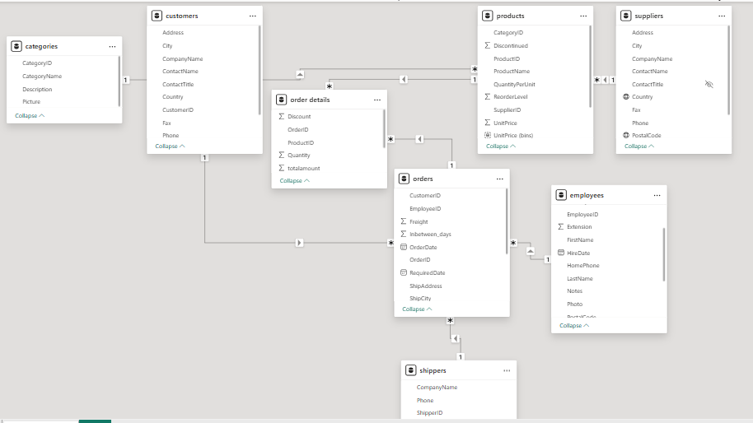
Here is our Northwind Traders Sales Analysis Dashboard 1-
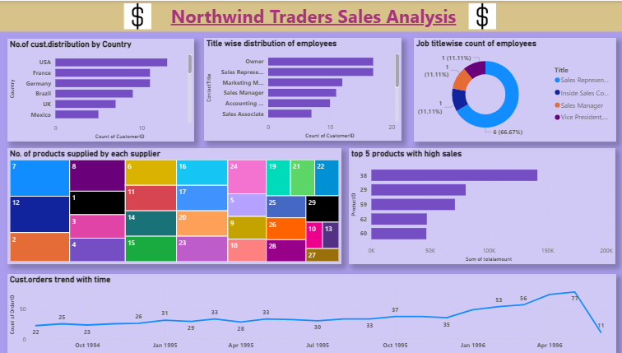

Here is our Sales Analysis Dashboard 2-
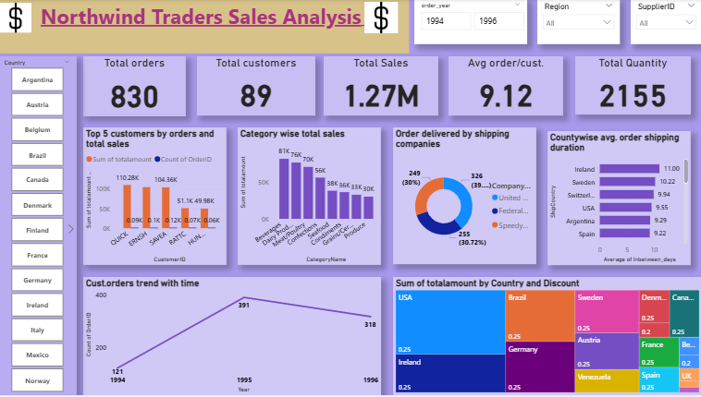

Here is our Sales Analysis dashboard 3-
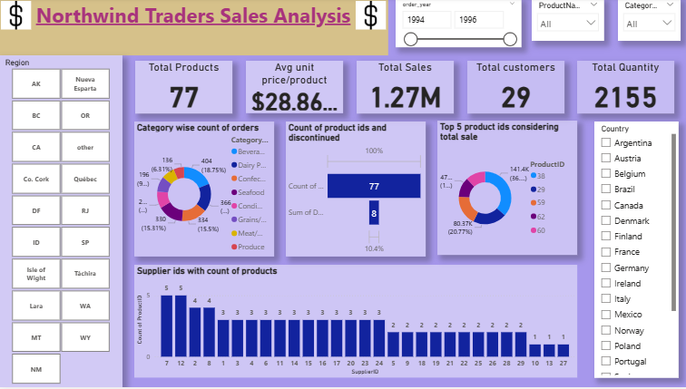

Step 5-link sharing on Github
Uploaded all files on Github and here is link to the repository

Conclusion-
The Northwind Traders Sales Analysis project successfully integrated and analyzed data from multiple sources — including customers, orders, products, suppliers, and categories — to generate meaningful business insights. Through structured data cleaning and transformation in Excel and SQL, inconsistencies were resolved, and relationships across datasets were clearly established.
Exploratory Data Analysis (EDA) revealed key sales trends, customer purchase patterns, and product performance indicators. Power BI visualizations provided an interactive and dynamic dashboard that allows stakeholders to explore sales by region, category, and time period, monitor employee performance, and identify high-value customers and top-selling products.

